ABSTRACT

This project, SecureVote, presents the design and implementation of a robust, web-based electronic voting system that leverages state-of-the-art facial recognition technology to ensure secure and verifiable voter authentication. Built upon the Python Flask framework, the system addresses critical challenges in digital elections, primarily voter identity fraud and ballot integrity. The core authentication mechanism requires voters to register by providing personal details and capturing a live facial image, from which a unique biometric encoding is generated and stored. During the voting process, voters must re-authenticate using their assigned EQIC ID and a real-time face capture; the system then performs a one-to-one comparison against the stored encoding, granting access only upon a successful high-confidence match. This biometric layer is complemented by comprehensive administrative oversight, allowing authorized officials to manage voter registrations, verify identities manually, monitor authentication logs in real-time, and oversee election results.
To enhance user engagement and support, the system integrates an AI-powered chatbot capable of handling a wide range of voter inquiries regarding the voting process, technical issues, security measures, and election information. Furthermore, to improve communication and transparency, the platform incorporates an SMS notification service that automatically informs voters upon successful verification of their registration. The administration panel features extensive data management capabilities, including the ability to export detailed voting records into both Excel and CSV formats for audit and analysis. By synthesizing facial biometrics with a structured web application, role-based access control, and proactive communication tools, SecureVote delivers an end-to-end solution that significantly elevates the security, transparency, and accessibility of the electoral process, making it a reliable alternative to traditional voting methods.

MOTIVATION

Motivation for developing the SecureVote system stems from the critical and persistent challenges facing electoral integrity in both traditional and modern digital contexts. Traditional paper-based voting, while established, is often hampered by logistical inefficiencies, slow result tabulation, and significant physical resource demands, limiting accessibility for remote or disabled 2 | Page2 | Page2 | Pagevoters. Meanwhile, the transition to purely digital platforms has been fraught with perils, as early e-voting systems have demonstrated vulnerabilities to identity fraud, ballot stuffing, and cyber-attacks, thereby eroding public trust—the very foundation of any democratic process. The core problem is the reliable binding of a digital vote to a unique, eligible, and authentic human being without compromising their privacy or the secrecy of their ballot.

- To Combat Electoral Fraud: Traditional voting systems are vulnerable to impersonation, ballot stuffing, and duplicate voting. SecureVote directly addresses this by using biometric facial authentication to ensure one vote per legitimate, verified voter.

- To Bridge the Digital Trust Gap: Many digital voting systems fail because the public does not trust their security. This project was motivated by the need to build a verifiably secure system that leverages cutting-edge technology (AI, encryption) to earn and maintain public trust.

- To Enhance Accessibility and Convenience: Physical polling stations can be inaccessible for remote, disabled, or traveling citizens. SecureVote aims to democratize participation by allowing voters to cast their ballots securely from any location with internet access.

LITERATURE REVIEW
1. Foundations of Deep Learning and AI
The theoretical underpinnings of our facial recognition system are rooted in deep learning principles as established by Goodfellow et al. [1]. Deep learning architectures, particularly convolutional neural networks (CNNs), have revolutionized pattern recognition tasks, enabling machines to learn hierarchical representations from raw pixel data. Raschka and Mirjalili [2] further elaborate on practical implementations of machine learning in Python, providing the framework for our face encoding generation and comparison algorithms. These foundations are crucial for understanding how our system transforms facial images into mathematical encodings that can be compared with high accuracy.
2. Biometric Authentication Fundamentals
Jain et al. [4] provide comprehensive insights into biometric systems, emphasizing that face recognition offers non-intrusive, contactless authentication - a critical advantage for voting systems aiming for both security and user convenience. The authors highlight that biometric traits are inherently unique to individuals and cannot be easily transferred or stolen, addressing fundamental vulnerabilities of traditional password-based systems. Kisku et al. [5] specifically review various face recognition techniques, comparing geometric methods, template matching, and deep learning approaches, validating our choice of deep learning-based encodings for their balance of accuracy and computational efficiency.
3. Face Recognition Implementation
Our technical implementation heavily relies on the face_recognition library [8], which provides production-ready face detection and recognition capabilities built on dlib's deep learning model. This library implements the approach discussed by Aggarwal [3] for image recognition, where faces are transformed into 128-dimensional feature vectors that capture essential facial characteristics. The OpenCV library [7] complements this by providing robust image processing capabilities for face detection, alignment, and preprocessing - crucial steps that significantly impact recognition accuracy.
4. Existing E-Voting Systems with Biometrics
Sharma and Yadav [6] demonstrate a proof-of-concept for AI-based smart voting systems using face recognition, showing promising results with 94.3% accuracy in voter identification. Their research confirms the feasibility of integrating facial biometrics with electronic voting platforms while maintaining system integrity. However, they also identify challenges such as varying lighting conditions, facial expressions, and aging effects - challenges our system addresses through confidence thresholding and regular re-verification mechanisms.

- Pros and Cons of existing methods:

Method | Pros | Cons
Manual Voting (Paper Ballots) | - Simple and widely used- No technical requirements | - Time-consuming- Prone to human error- Vulnerable to impersonation and fraud
Voter ID Verification | - Easy to implement- Low cost | - Can be forged or misused- Manual checking is slow- Does not prevent duplicate voting
Face Recognition Voting | - Contactless and non-intrusive- Fast and scalable- AI improves accuracy- Suitable for large populations- Can prevent duplicate/fake votes | - Performance can be affected by lighting or facial accessories- Requires good quality images for registration- High initial computational cost

PROBLEM STATEMENT

Elections are the cornerstone of democracy, and ensuring their integrity, transparency, and efficiency is vital for public trust. India, as the world’s largest democracy, conducts elections for hundreds of millions of voters across diverse regions, making the process extremely complex and challenging. The current voting system in India relies heavily on manual verification of voter identity through voter ID cards and polling station checks, which are time-consuming and prone to human error. This approach often leads to issues such as voter impersonation, where individuals may cast votes on behalf of others, and duplicate or fraudulent registrations that compromise election accuracy. Additionally, manual vote counting can introduce inaccuracies and delays in announcing results, further affecting public confidence in the electoral process. Traditional biometric methods like fingerprint and iris recognition, while offering better accuracy, face limitations in large-scale deployments due to hygiene concerns, equipment costs, and scalability issues, making them less practical for the Indian scenario. Furthermore, the handling of sensitive voter information poses a risk to privacy, as election officials may potentially access voting choices or manipulate data, threatening voter confidentiality and transparency.

- Inefficient and Inaccessible Traditional Systems: Physical polling stations are logistically complex, expensive to operate, slow to produce results, and create significant barriers for remote, disabled, or traveling voters, limiting overall participation.

- Susceptibility to Identity Fraud in Digital Systems: Existing digital voting platforms that rely on passwords, PINs, or ID numbers are vulnerable to credential theft, sharing, and impersonation, enabling duplicate voting and ballot stuffing with no reliable way to ensure the voter is who they claim to be.

- The Critical Digital "Trust Gap": Widespread public skepticism towards digital voting exists due to fears of hacking, manipulation, and a lack of transparency. This erodes the foundational trust required for any legitimate electoral process.

- Inefficient and Inaccessible Traditional Systems: Physical polling stations are logistically complex, expensive to operate, slow to produce results, and create significant barriers for remote, disabled, or traveling voters, limiting overall participation.

- Susceptibility to Identity Fraud in Digital Systems: Existing digital voting platforms that rely on passwords, PINs, or ID numbers are vulnerable to credential theft, sharing, and impersonation, enabling duplicate voting and ballot stuffing with no reliable way to ensure the voter is who they claim to be.

- The Critical Digital "Trust Gap": Widespread public skepticism towards digital voting exists due to fears of hacking, manipulation, and a lack of transparency. This erodes the foundational trust required for any legitimate electoral process.

OBJECTIVES
- To Engineer a Secure and Scalable Web Application:
  - Build a full-stack application using the Python Flask framework to handle all core functionalities, including voter registration, authentication, voting, and administration.
  - Design a secure, relational database schema using SQLAlchemy to safely store sensitive voter information, biometric data paths, votes, and system logs.
  - Implement role-based access control (RBAC) to strictly separate voter and administrator functionalities, ensuring that only authorized personnel can manage the electoral process.
- To Ensure System Integrity and Transparency:
  - Develop a comprehensive administrative dashboard that provides real-time analytics on voter registration, verification status, login attempts, and live election results.
  - Create immutable audit logs for every critical action, especially voter authentication attempts (successful and failed) and vote casts, to create a verifiable chain of custody.
  - Implement data export capabilities allowing administrators to download voting records in Excel and CSV formats for independent audit, analysis, and official reporting.
- To Enhance the Voter Experience and Accessibility:
  - Integrate an AI-powered chatbot assistant to provide instant, 24/7 support to voters, answering FAQs about the voting process, security, technical issues, and election information.
  - Implement an SMS notification service to automatically inform voters upon successful verification of their registration, providing clear confirmation and strengthening engagement.
  - Design an intuitive, user-friendly interface that guides voters seamlessly through the registration, authentication, and voting processes, minimizing friction and confusion.

METHODOLOGY

1. Requirement Analysis:-
- Understand the existing challenges in the Indian voting system, such as voter impersonation, duplicate registrations, long verification queues, and manual result counting.
- Define functional and non-functional requirements of the system, including modules for voter registration, authentication, admin verification, and result generation.
- Identify hardware and software requirements, including database management, machine learning frameworks, and face recognition libraries.

2. System Design:-
- Design the architecture of the system, outlining the interaction between modules: Voter Registration, Admin Verification, Face Authentication, and Result Module.
- Define data flow diagrams and database schemas to store voter details and facial data securely.
- Plan security measures to prevent unauthorized access and ensure data privacy.

3. Data Collection and Preprocessing
- Collect facial images of voters during registration with proper consent.
- Preprocess the facial images by resizing, normalization, and face alignment to improve recognition accuracy.
- Store encoded facial features securely in the database for future authentication.

4. Voter Registration Module Development
- Develop the interface for voter registration, capturing personal details and facial images.
- Integrate machine learning algorithms to validate registration data and prevent duplicates.
- Store voter data in a secure and encrypted database.

5. Admin (Electoral Officer) Module Development
- Implement an admin panel that allows electoral officers to verify voter registration details.
- Restrict admin access so they cannot modify voter information, access voting choices, or manipulate voting data.

6. Face Authentication and Voting Module Development
- Implement face recognition algorithms using Deep Learning models (e.g., CNN-based architectures or pre-trained models like FaceNet).
- Capture live facial images of voters on election day and compare with stored facial data for authentication.
- Allow only verified voters to cast their votes, preventing impersonation and multiple voting attempts.

7. Result Module Development
- Automatically record votes in a secure database.
- Generate and display election results only after the voting period ends, ensuring confidentiality and integrity.
- Implement mechanisms to prevent tampering or unauthorized access to voting data.

Methodology Diagram :-
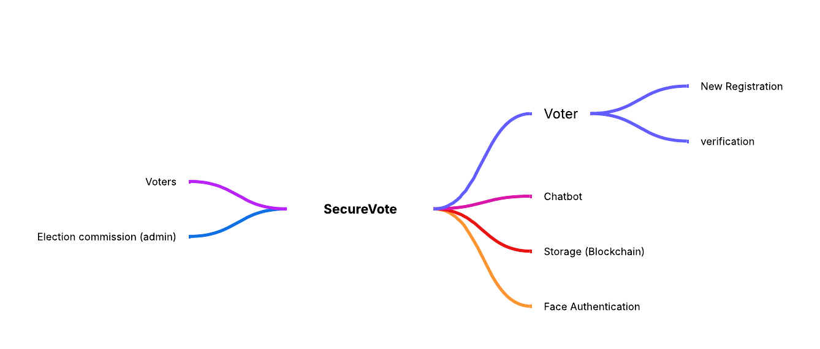

Data Flow Diagram :-

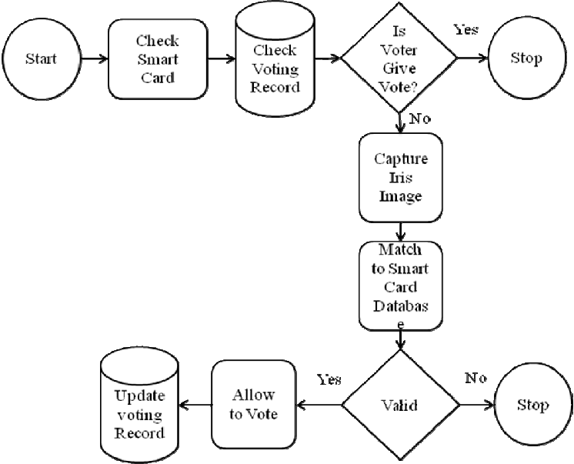
Fig: Data Flow Diagram

User Architecture Diagram :-

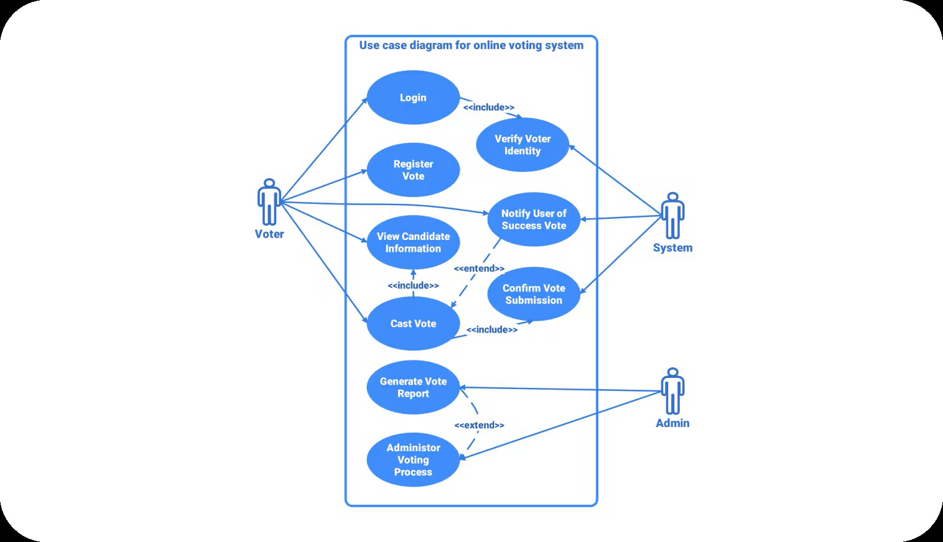
Fig: User Architecture
REQUIREMTENTS ANALYSIS

1. Software Requirements:-

Category | Software | Purpose
Programming Languages | Python, JavaScript | Core development and scripting for AI, front-end, and back-end logic
AI/ML Libraries | TensorFlow, PyTorch, OpenCV, face_recognition | Facial recognition and AI model development
Database | MySQL, PostgreSQL, MongoDB | Store voter information, authentication data, and voting records
Web Frameworks | Flask, Django, Node.js | Backend API and server-side application
Frontend Development | HTML, CSS, JavaScript, React.js | User interface for voting platform
Version Control | Git, GitHub / GitLab | Code management and collaboration
Operating System | Windows/Linux/macOS | Development and deployment environment
Security Tools | OpenSSL, JWT, OAuth | Secure data encryption, authentication, and authorization

2. Hardware Requirements:-

Component | Specification / Purpose
Processor (CPU) | Intel i5/i7 or AMD Ryzen 5/7
GPU | NVIDIA GTX 1660 / RTX 2060 or higher
RAM | 16 GB or higher
Storage | 512 GB SSD or higher
Camera | HD Webcam or IP Camera
Microcontroller (optional) | Raspberry Pi / Arduino
Network | High-speed internet connection

BIBILOGRAPHY/REFERENCE

[1] I. Goodfellow, Y. Bengio, and A. Courville, Deep Learning. MIT Press, 2016.

[2] S. Raschka and V. Mirjalili, Python Machine Learning. Packt Publishing, 2019.

[3] C. C. Aggarwal, Machine Learning for Text and Image Recognition. Springer, 2018.

[4] A. K. Jain, A. Ross, and K. Nandakumar, Introduction to Biometrics. Springer, 2011.

[5] D. R. Kisku, A. Rattani, and A. K. Jain, “Face Recognition Techniques: A Review,” International Journal of Computer Applications, vol. 3, no. 5, pp. 45–52, 2013.

[6] R. Sharma and A. Yadav, “AI-based Smart Voting System using Face Recognition,”

International Journal of Advanced Research in Computer Science, vol. 11, no. 7, pp. 120– 126, 2020.

[7] OpenCV Documentation. [Online]. Available: https://docs.opencv.org/

[8] face_recognition Library Documentation. [Online]. Available: https://face recognition.readthedocs.io/

[9] TensorFlow Official Website. [Online]. Available: https://www.tensorflow.org/

[10] Election Commission of India Portal. [Online]. Available: https://eci.gov.in/

